MANAGEMENT INFORMATION SYSTEM

LAB EXPERIMENTS

Jashwini A-192124192

6) Draw a Use case diagram to model for a quiz system. A user can request a quiz for the  system. The system picks a set of questions from its database, and composes them  together to make a quiz. It rates the user’s answers and gives hints if the user requests  it. In addition to users, we also have helpers who provide questions and hints. And also,  administrators who must certify questions to make sure they are not too trivial, and that they are correct.

**Aim:**

To develop a **Use Case Diagram** for a **Quiz System**, illustrating the interactions between users, helpers, and administrators.

**Procedure:**

1. **Identify Key Actors:**
   * **User**: Takes quizzes and requests hints.
   * **Helper**: Provides questions and hints.
   * **Administrator**: Certifies questions for accuracy and difficulty.
   * **Quiz System**: Manages quizzes and evaluates responses.
2. **Define the Activities (Use Cases):**
   * **User Use Cases:**
     + Request Quiz
     + Answer Questions
     + Request Hint
     + Receive Rating
   * **Helper Use Cases:**
     + Provide Questions
     + Provide Hints
   * **Administrator Use Cases:**
     + Certify Questions
   * **System Use Cases:**
     + Generate Quiz
     + Evaluate Answers
3. **Establish Relationships:**
   * The **User** interacts with the **Quiz System** to take quizzes, answer questions, and request hints.
   * The **Helper** provides questions and hints to the **Quiz System**.
   * The **Administrator** reviews and certifies questions before they are included in the quiz.
   * The **Quiz System** generates quizzes, evaluates answers, and provides ratings to users.

**Output:**

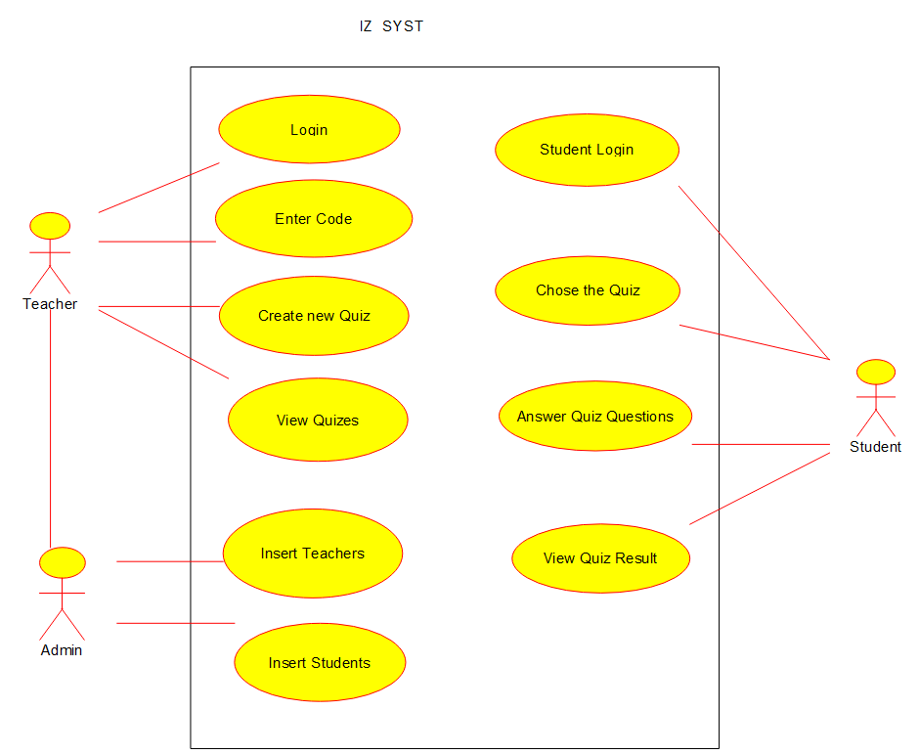

**Use case diagram**

**Result:**

A **UML Use Case Diagram** will be created based on the above design.